[Enter Post Title Here]

VI. Changing directions
Driving through roundabouts

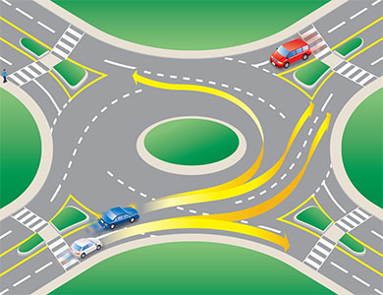
Diagram 2-36

Approaching:
- As you approach the roundabout, look for signage to choose your exit. Choose which lane to use as you would for any other intersection (See Diagram 2-36). Use the left lane to turn left or to go straight. Use the right lane to turn right or to go straight. (See Diagram 2-37). Do not enter a roundabout from the right lane if you want to turn left. Cyclists generally keep to the centre of the appropriate lane, or dismount and use the roundabout as a pedestrian would. (See Diagram 2-38.)
- Slow down and watch for pedestrians on the approach to the yield line at the entrance of the roundabout. Stay in your lane.
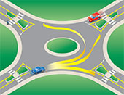
Diagram 2-37

Entering:
- Visual checks: Do visual checks of all vehicles already in the roundabout and those waiting to enter (including cyclists).
- Look left: Traffic in the roundabout has the right-of-way. When preparing to enter the roundabout, pay special attention to the vehicles to your left. Adjust your speed or stop at the yield sign if necessary.
- Adequate gap: Watch for a safe opportunity to enter the roundabout. Enter when there is an adequate gap in the circulating traffic flow. Don’t enter directly beside another already in the roundabout, as that may be exiting at the next exit.
- Travel counter-clockwise: Once in the roundabout, always keep to the right of the central island and travel in a counter-clockwise direction.
- Keep moving: Once you are in the roundabout, do not stop except to avoid a collision; you have the right-of-way over entering traffic. Do not change lanes while in the roundabout. If in the inside lane and you miss your exit, you must continue around until you meet your exit again.

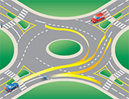
Diagram 2-38

Exiting:
- Signal: Be sure to signal your exit and watch for pedestrians.
- Maintain your lane: Stay to the left if you entered from the left lane, or stay to the right if you entered from the right lane.
- Maintain your position: Maintain your position relative to other vehicles.
- Signal intent to exit: Once you have passed the exit before the one you want, use your right-turn signal.
- Left lane exit: If exiting from the left lane, watch out for vehicles on the right that continue to circulate around the roundabout.

