With our unforgiving Nova Scotia winters, if you don’t adjust your driving behaviour for road conditions, you may be a collision waiting to happen.
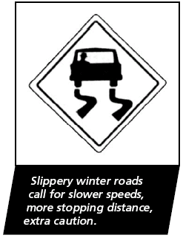
Reduce speed
The top reason for winter car collisions is “driving too fast for the conditions.”
Remember, the speed limit is for ideal conditions – snow, ice and reduced visibility call for lower speeds. This sometimes means driving far below the speed limit.
Test the road and your vehicle
When you start driving, test your braking, acceleration and steering to get a feel for the road surface and adjust your driving accordingly. Remember road conditions can change quickly in some areas but this can give you a guide as to what you may expect.
Deal with reduced traction
You must accelerate and brake more gradually when there’s reduced
traction. As you approach an intersection, scan for better traction areas such as bare pavement that your tires can grab onto and assist you in stopping.
Increase your braking distance
Remember that your stopping distance increases with changes in road conditions. Could be up to 16 times longer on ice, so when you are going to brake, make sure you start braking sooner and smooth avoiding any skidding.
Location matters, too
Bridges and approaches to intersections can be especially slippery. Always increase and decrease your speed gradually and avoid changing lanes abruptly.

